  
College of Engineering and Computer Science

***CSE 581 – Introduction to Database Management Systems***

***Project– 3***

***DB Design in SQL for a University Database***

***Submitted by: Rishi Siddanth Yaga - 627161225 -*** [***riyaga@syr.edu***](mailto:riyaga@syr.edu)

**This Project is done in ‘CSE 581 Projects’ under NetID ‘riyaga.’**

***DESCRIPTION OF DESIGN:***

The university database, named "riyaga," is a comprehensive relational database designed to manage various aspects of a university's administrative and academic operations. This database serves as the central repository for storing information about students, faculty, courses, departments, and campus facilities. It is intended to support the efficient management of university resources and enhance decision-making processes.

***VIEW:***

1. ***BENEFITS VIEW:*** The ‘Benefits’ view consolidates employee benefits information by joining EmployeeInfo, PersonInfo, EmployeeBenefits, BenefitType, and BenefitCoverage tables, displaying each employee's name, ID, benefit types, coverages, and premiums. It grants the 'Graders' role permission to query this view, facilitating easy access to detailed benefits data.

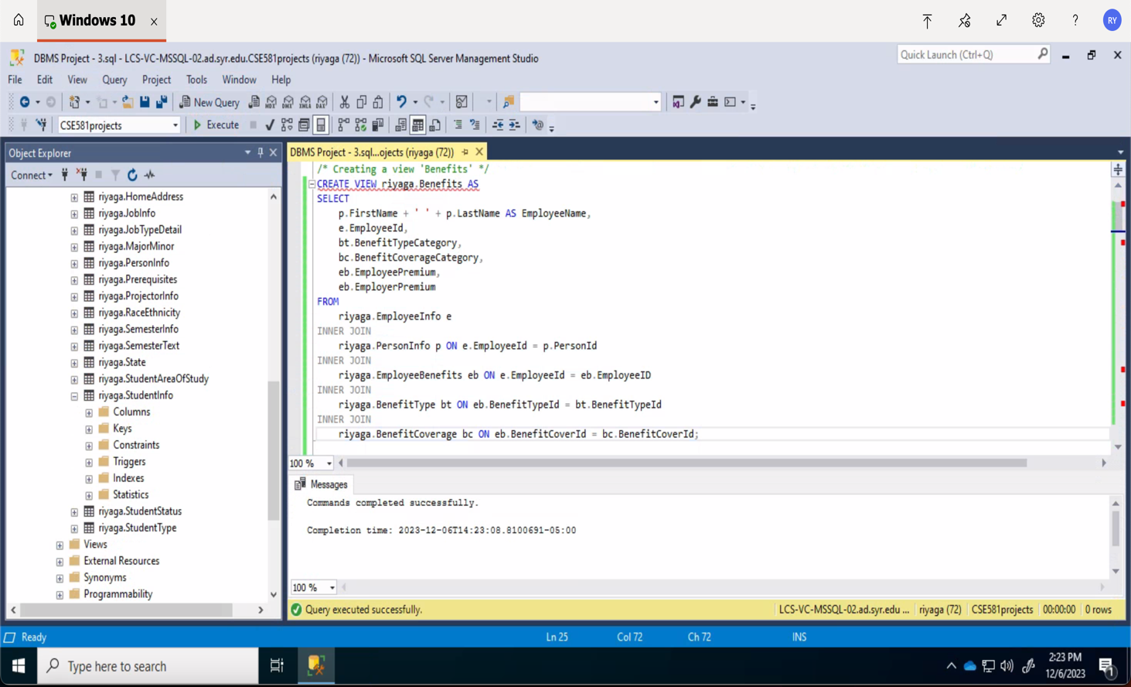

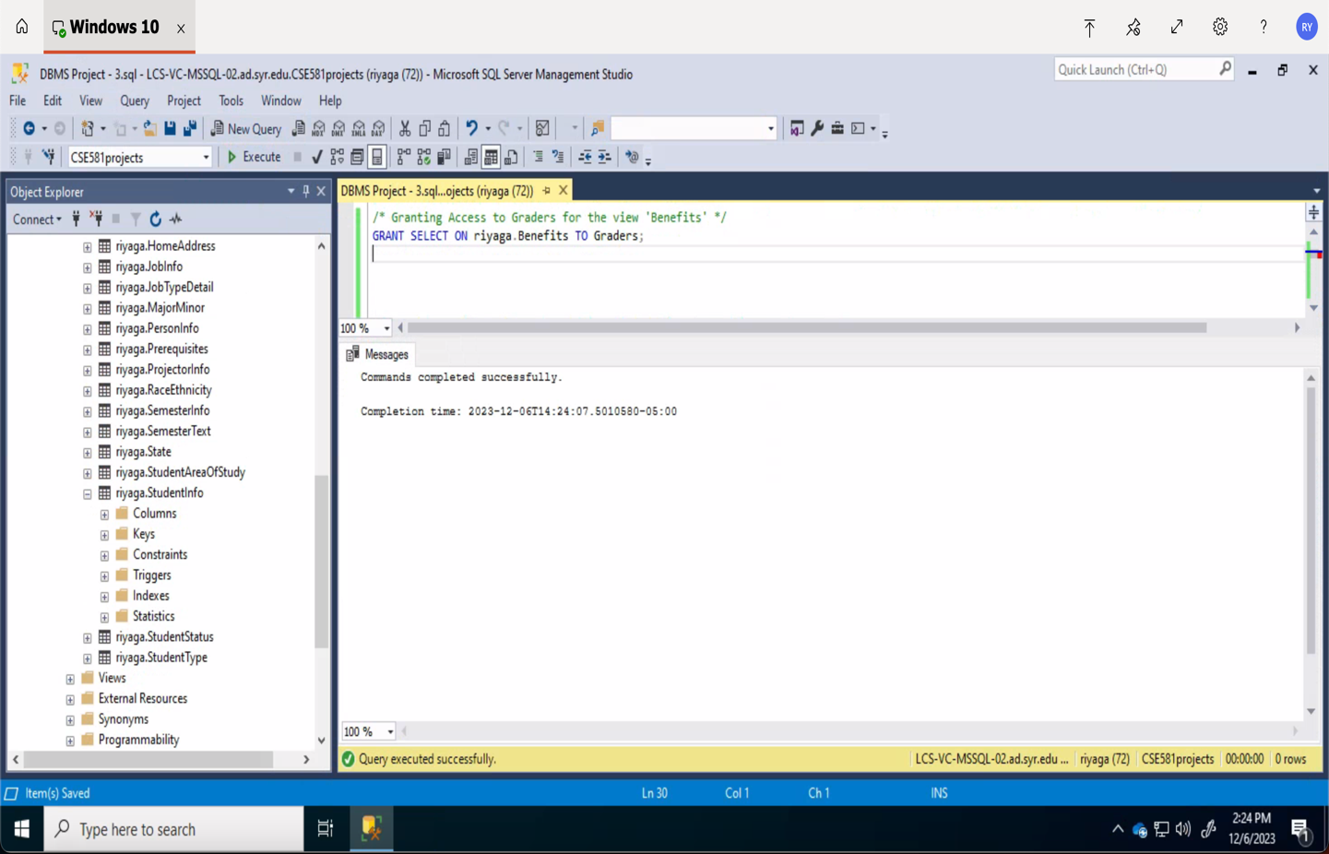

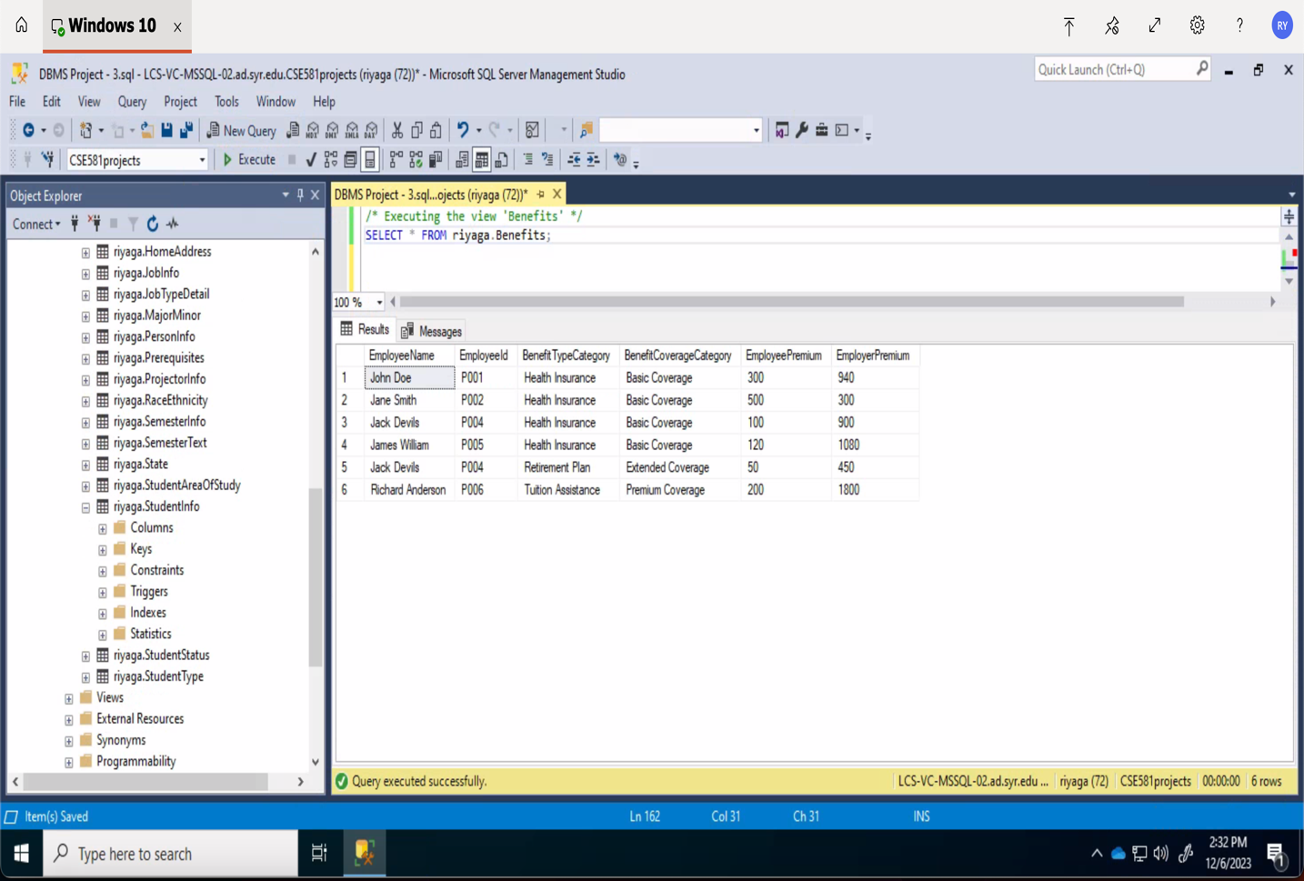

***FUNCTION:***

1. ***GetTotalStudentsInMajor:*** The function GetTotalStudentsInMajor calculates and returns the total number of students majoring in a specified area of study, identified by AreaOfStudyId. It also grants the 'Graders' role execution rights, allowing them to utilize this function to retrieve major-specific student counts.

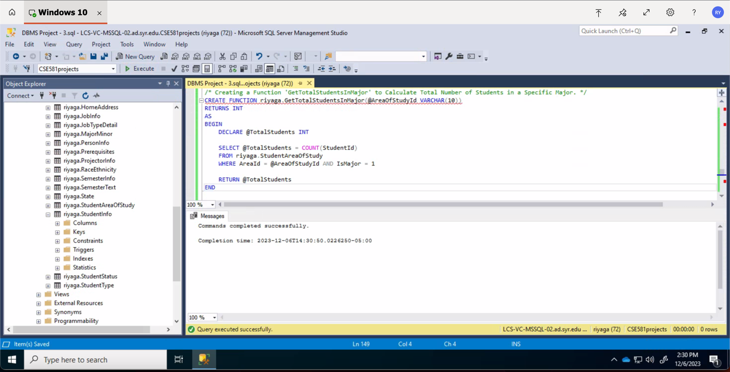

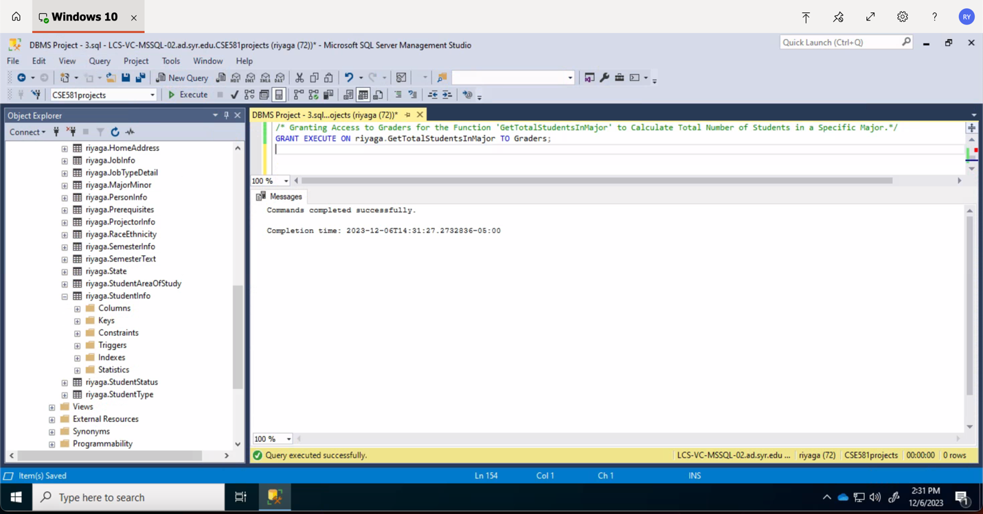

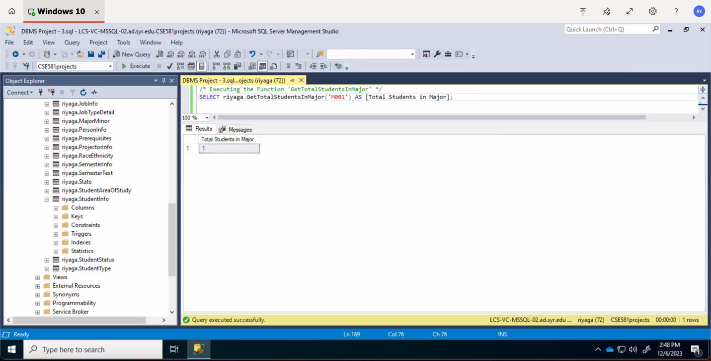

***STORED PROCEDURES:***

1. ***Stored Procedure To Use Cursors:***

**‘GetAllStudentsWithCursor’ :** This procedure uses a cursor to iterate through and print the IDs of all students in the StudentInfo table, providing a simple way to list all students.

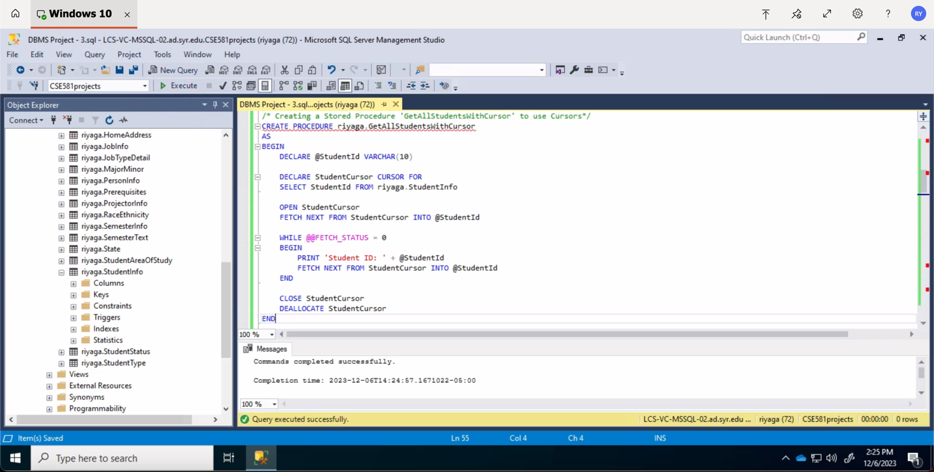

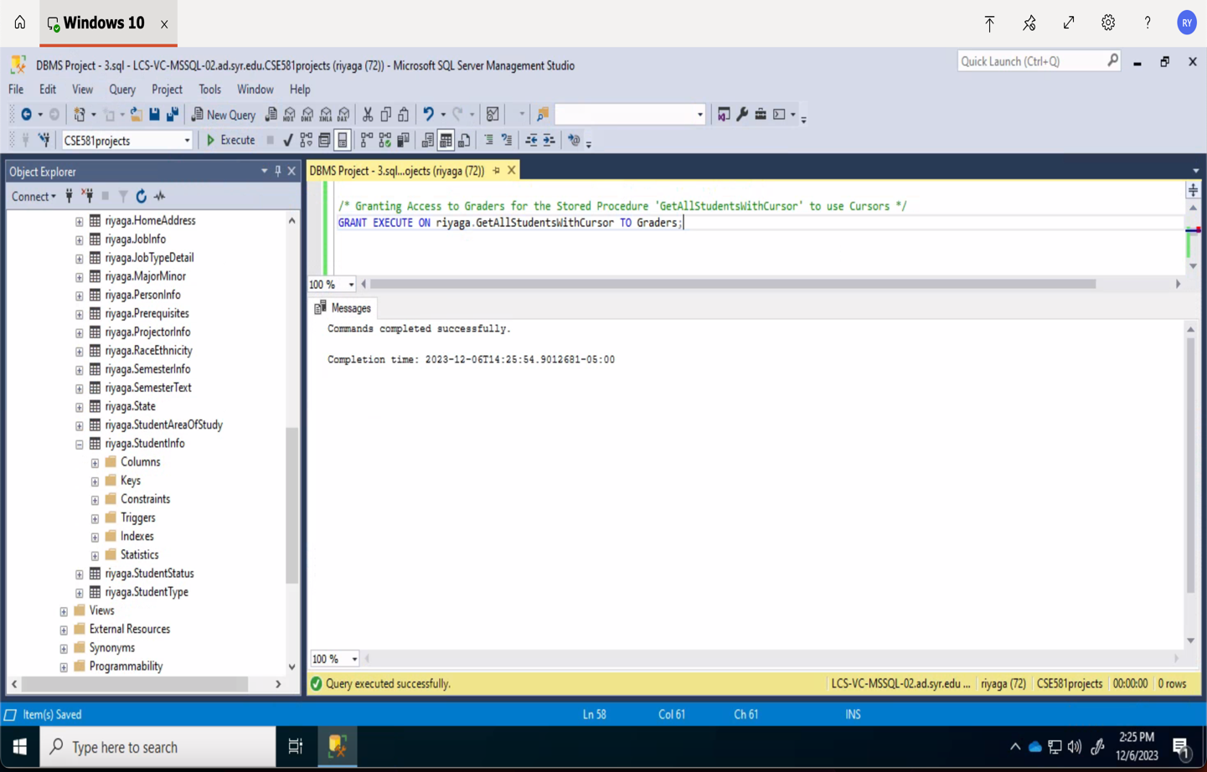

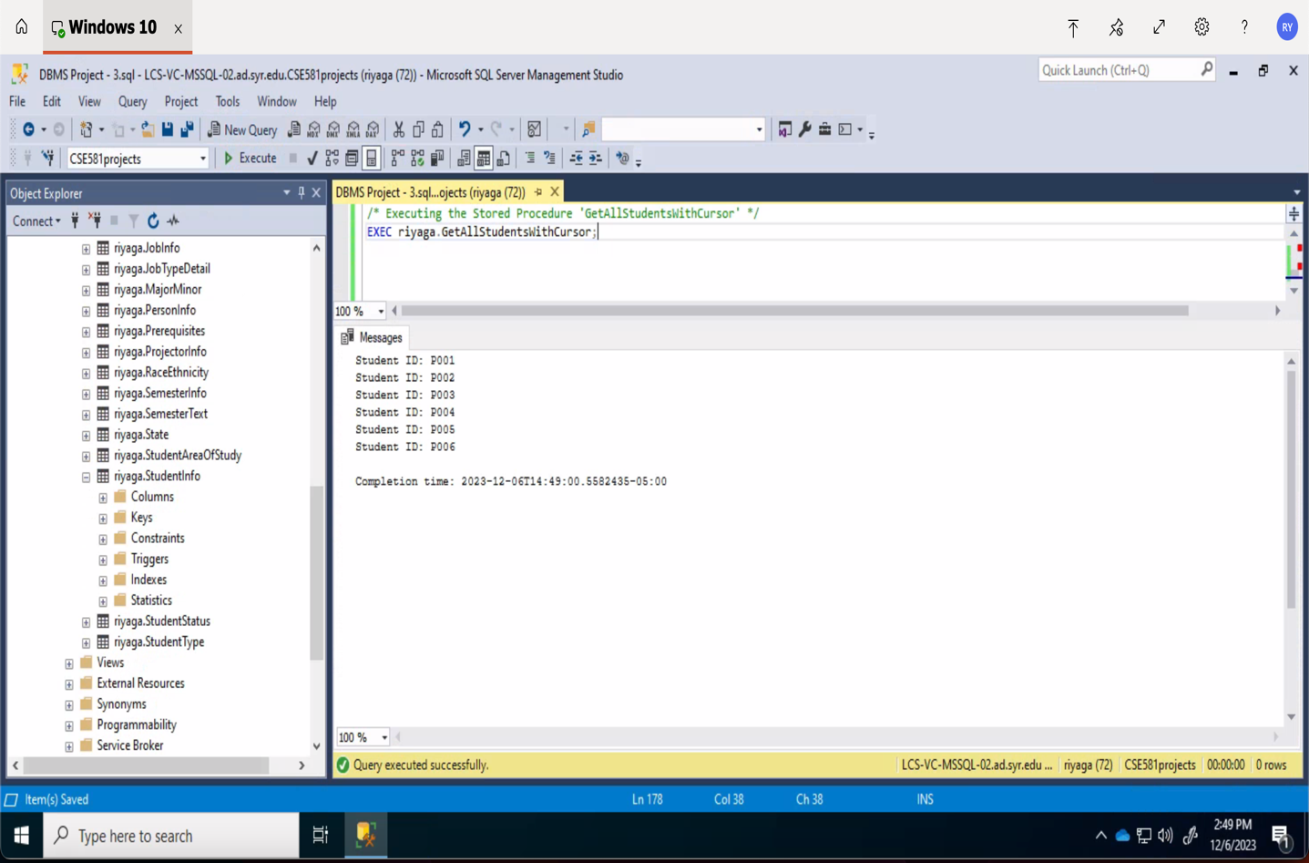

1. ***Stored Procedure To Update Data in a Table (Perform Validation):***

**‘UpdateStudentStatus’:** It allows updating a student's status in the StudentInfo table by validating the student ID and then setting a new status, ensuring data integrity.

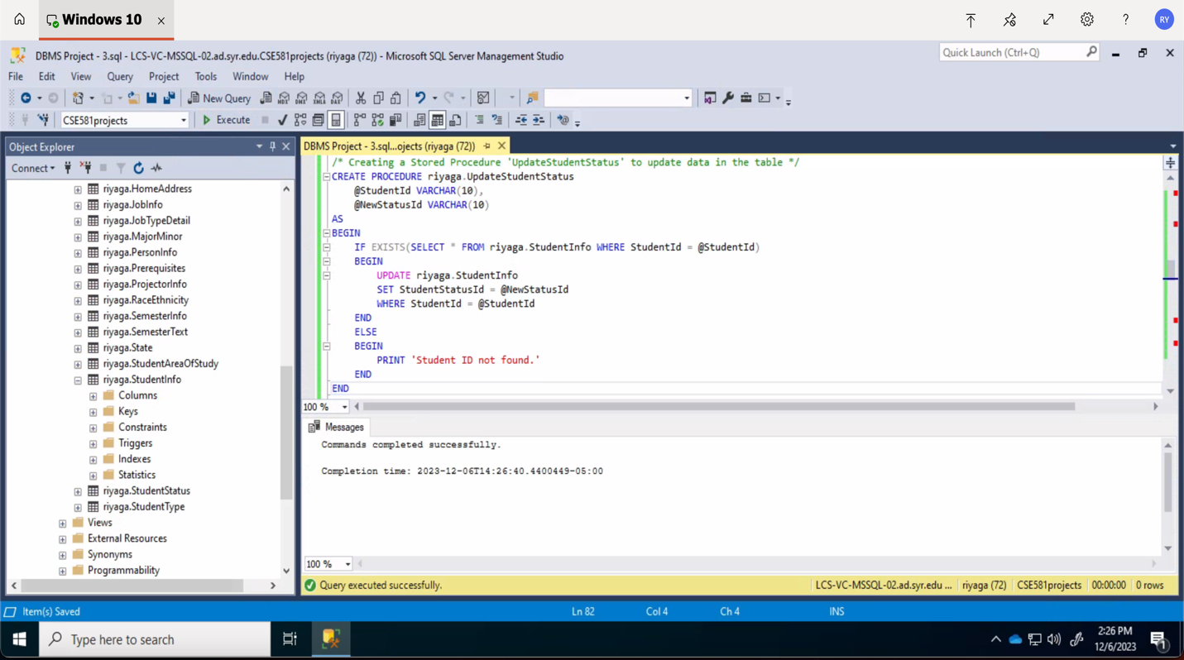

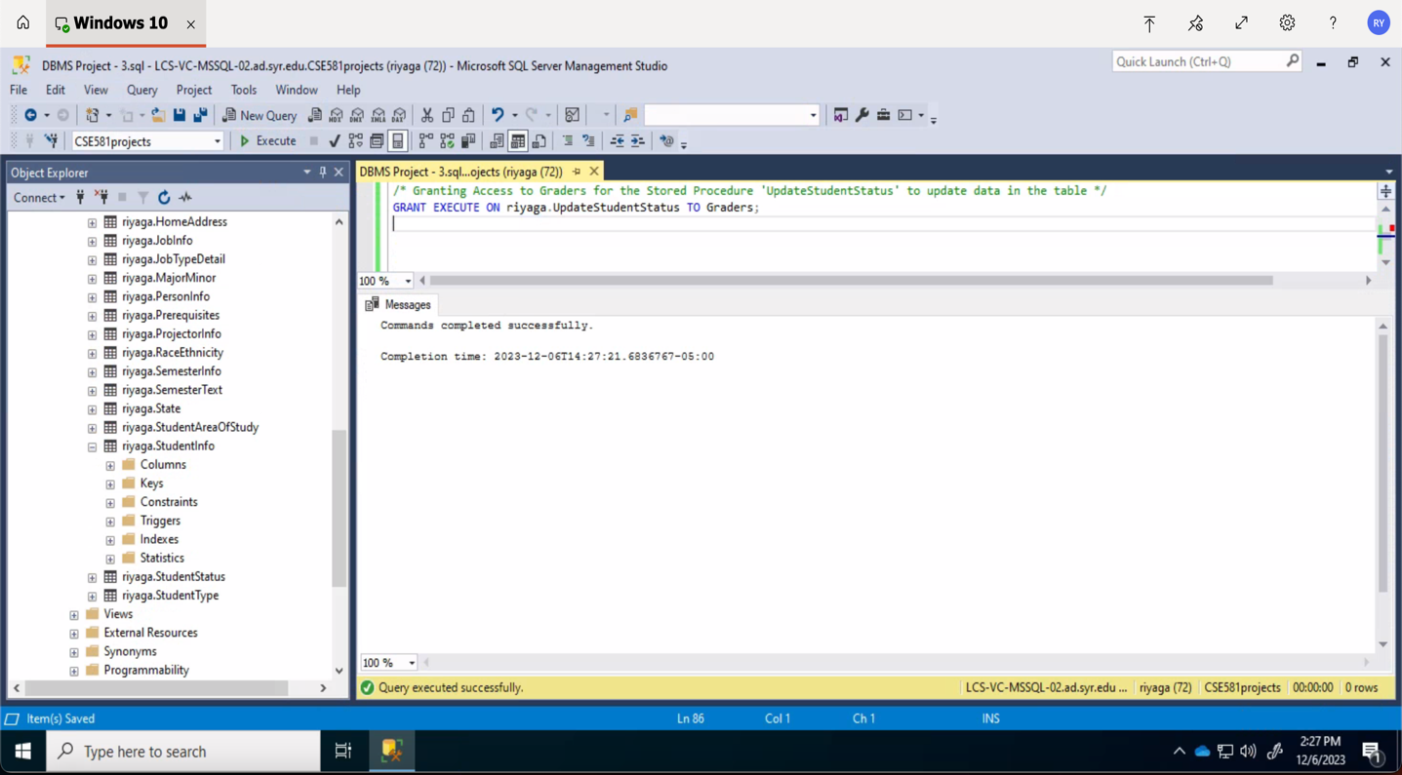

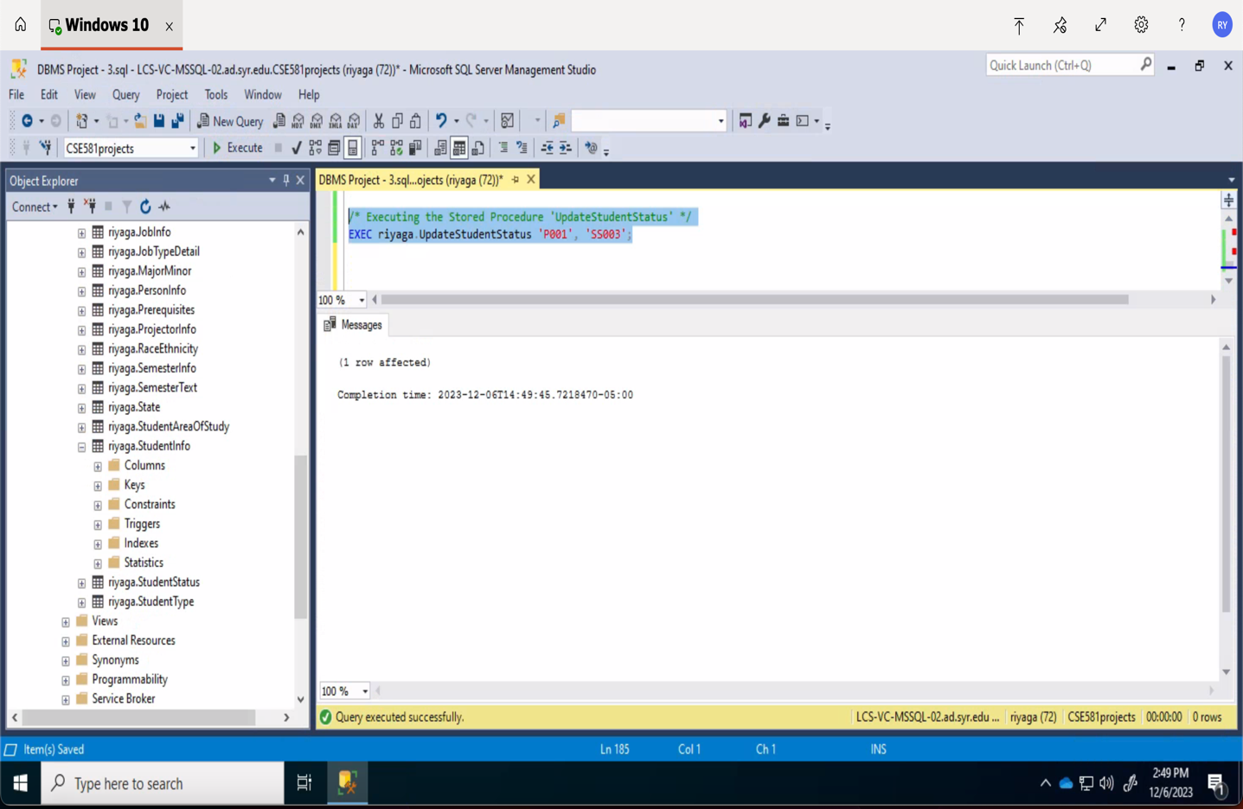

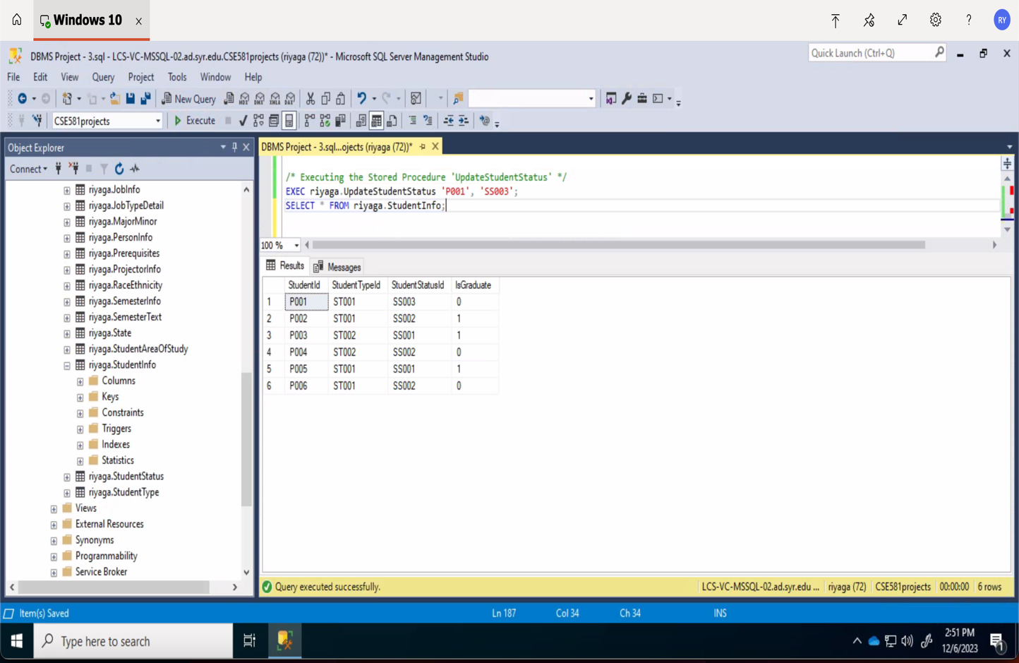

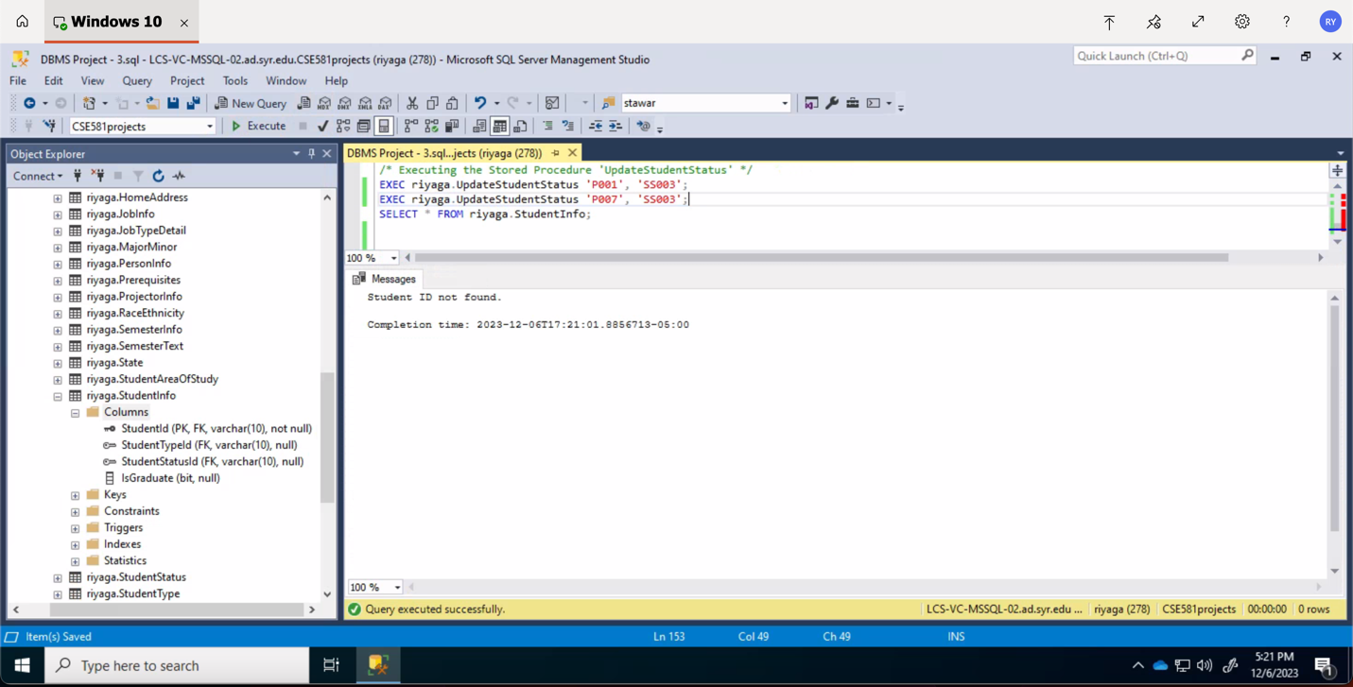

1. ***Stored Procedure to Delete Data from a Table:***

**‘DeleteStudent’ :**This procedure deletes a student's record from the StudentInfo table after confirming the student's ID exists, offering a secure method for student data removal.

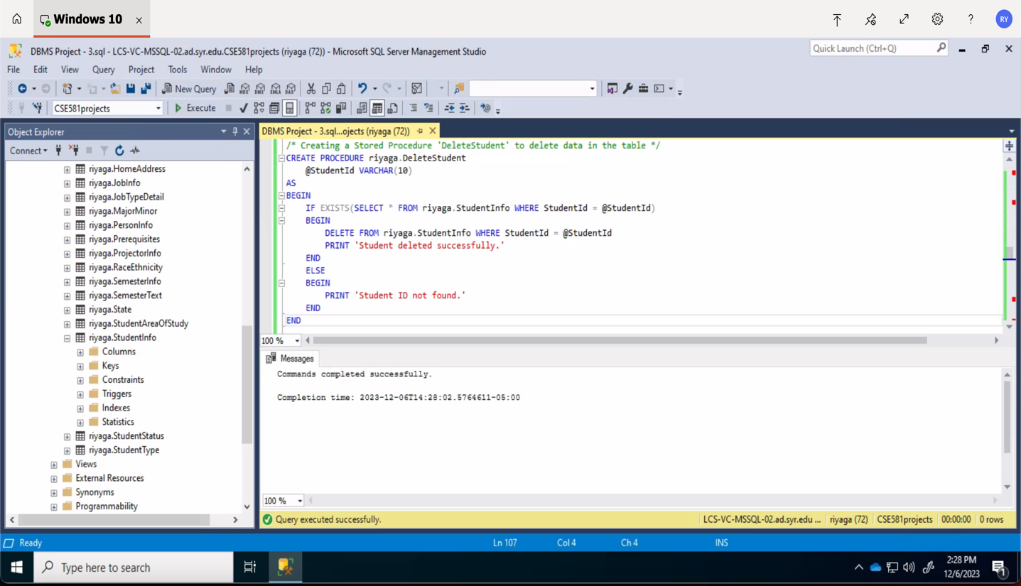

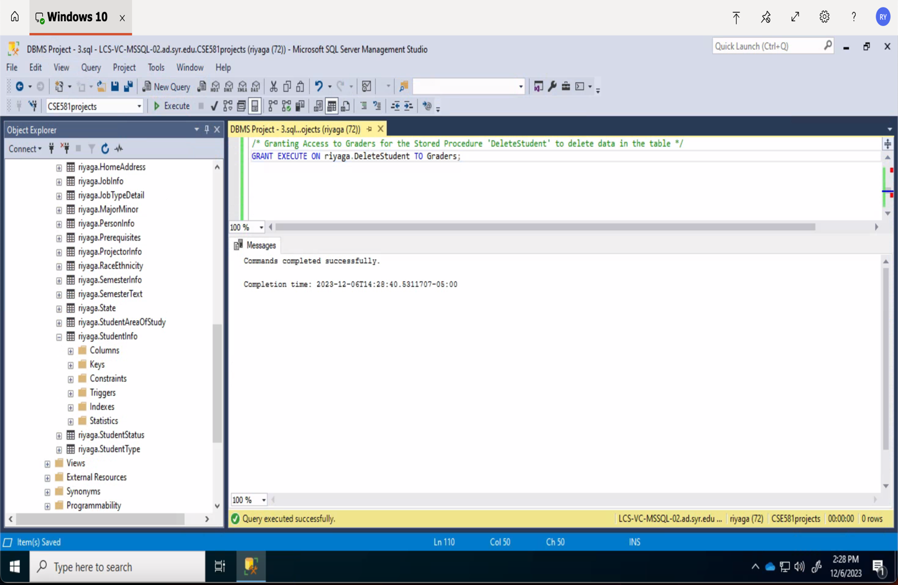

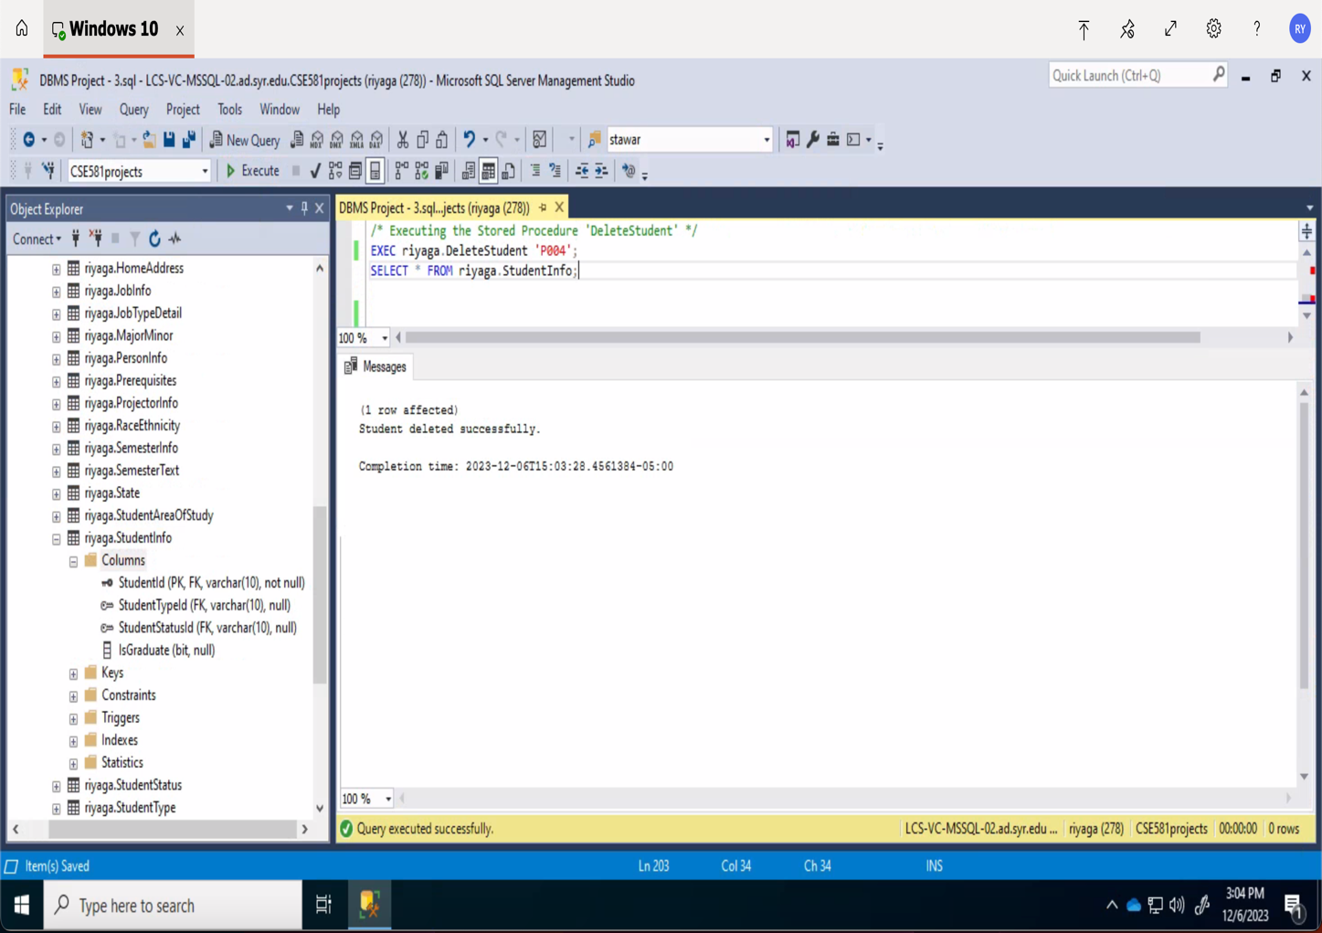

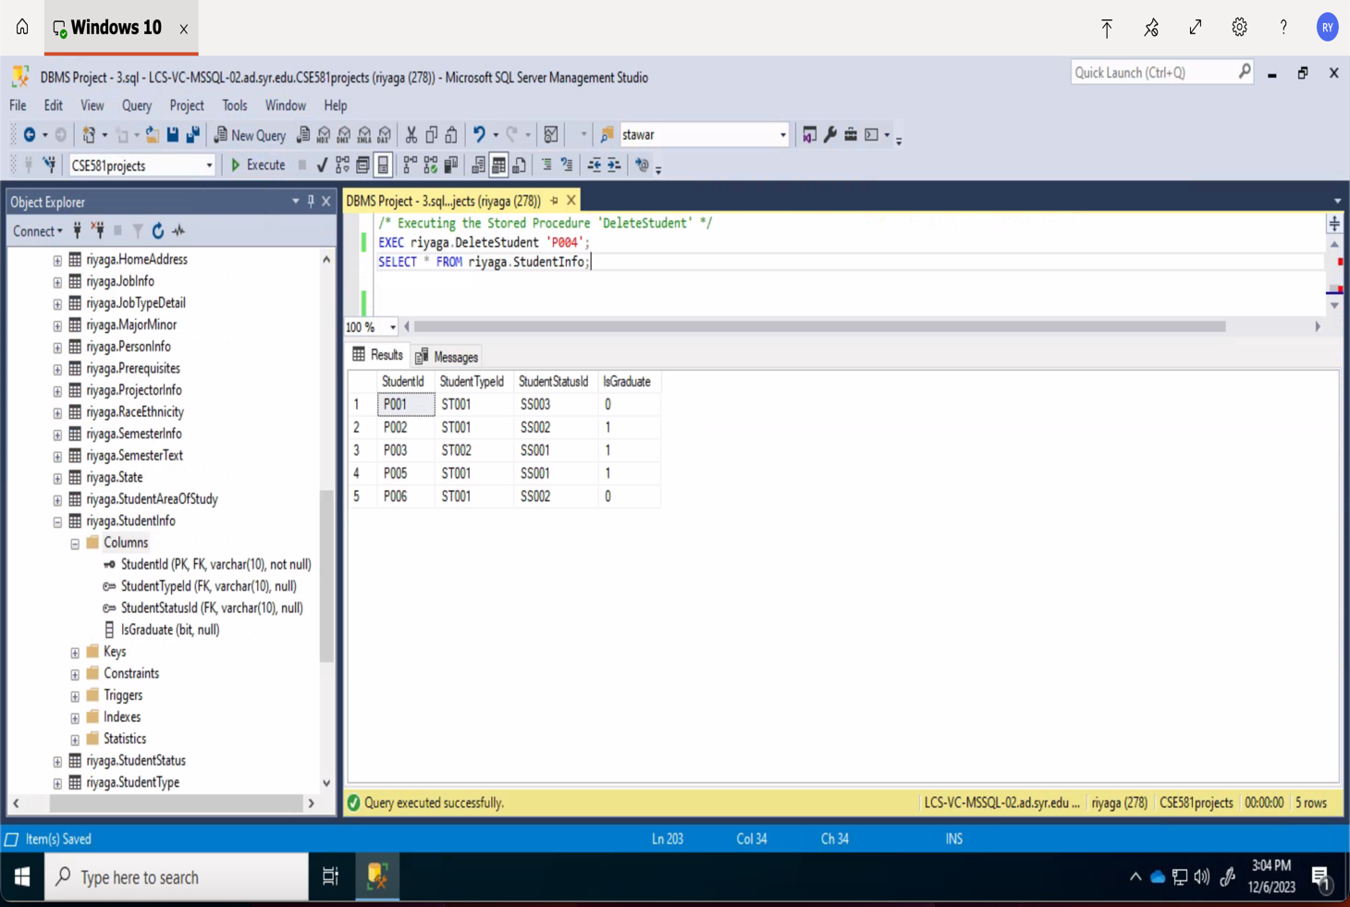

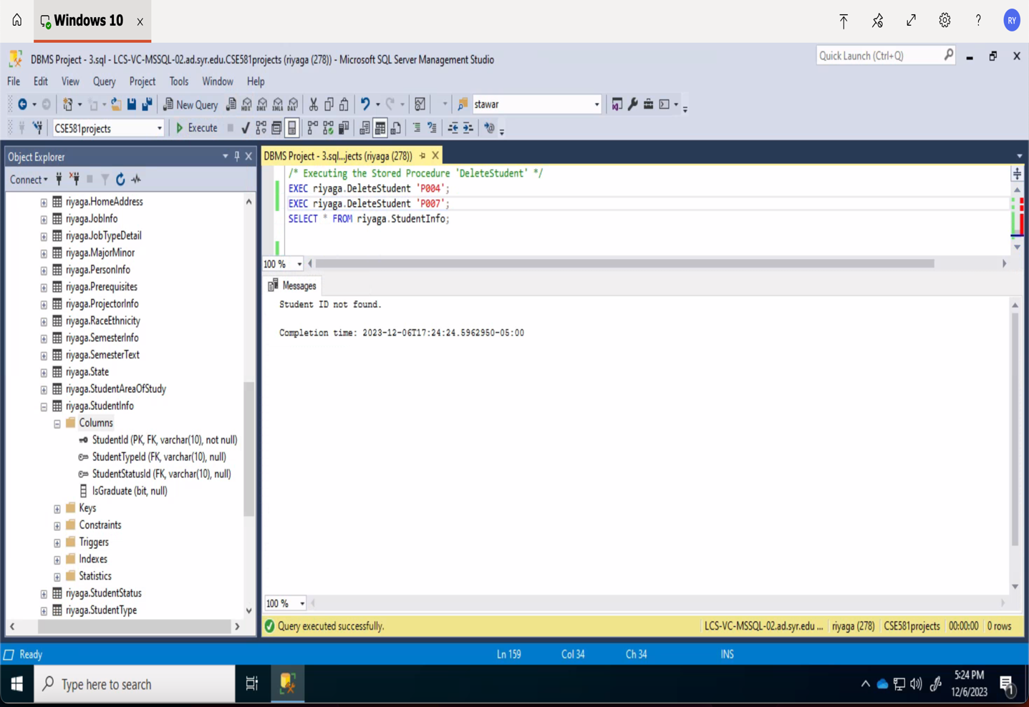

1. ***Stored Procedure of your own choice, performing a business action:***

**‘CalculateAverageGrade’ :**It calculates and returns the average final grade for a course identified by its CRN, aiding in academic performance analysis.

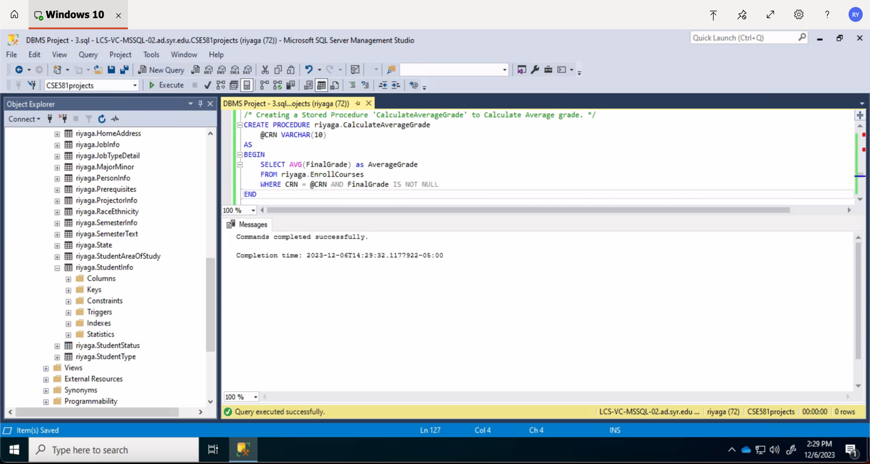

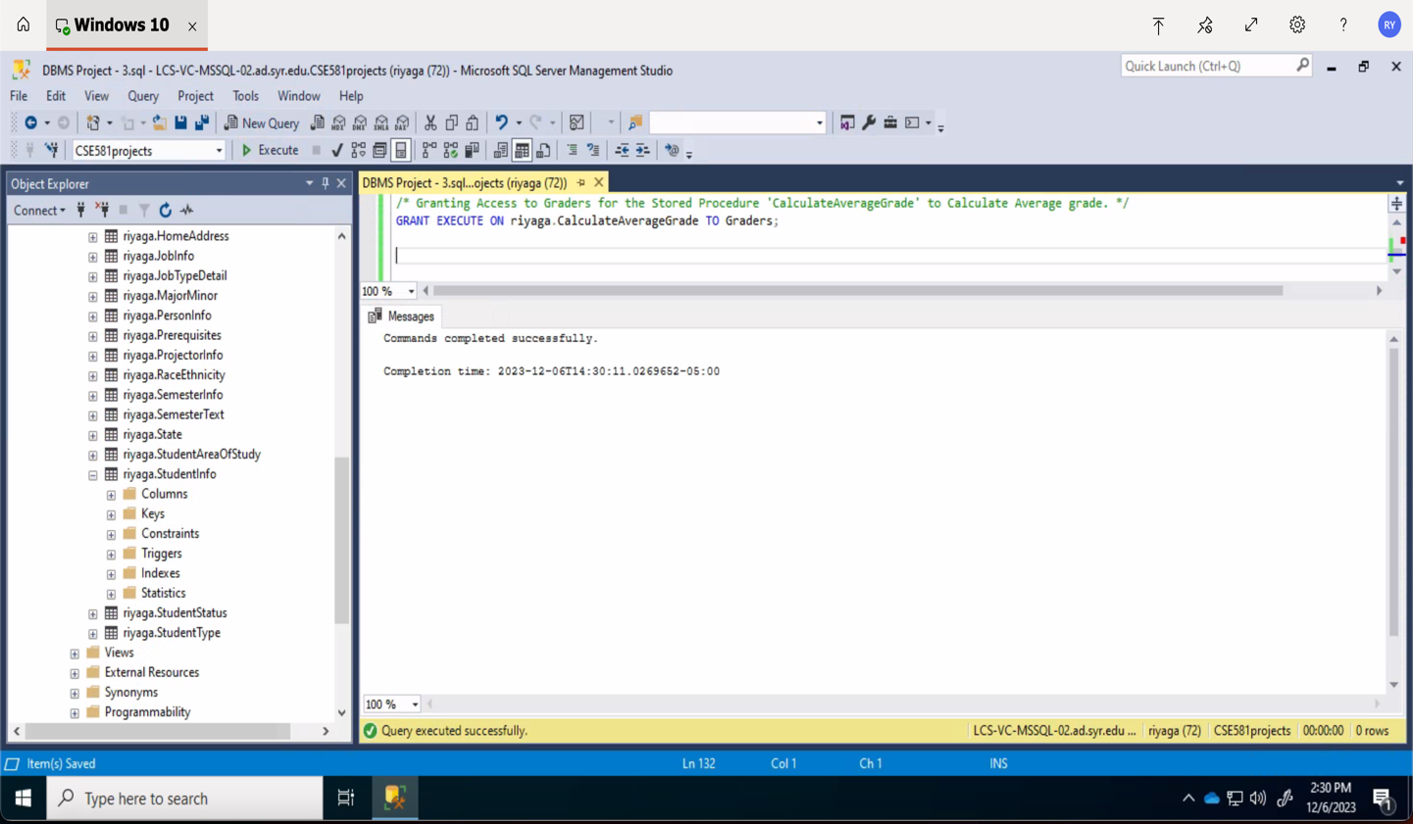

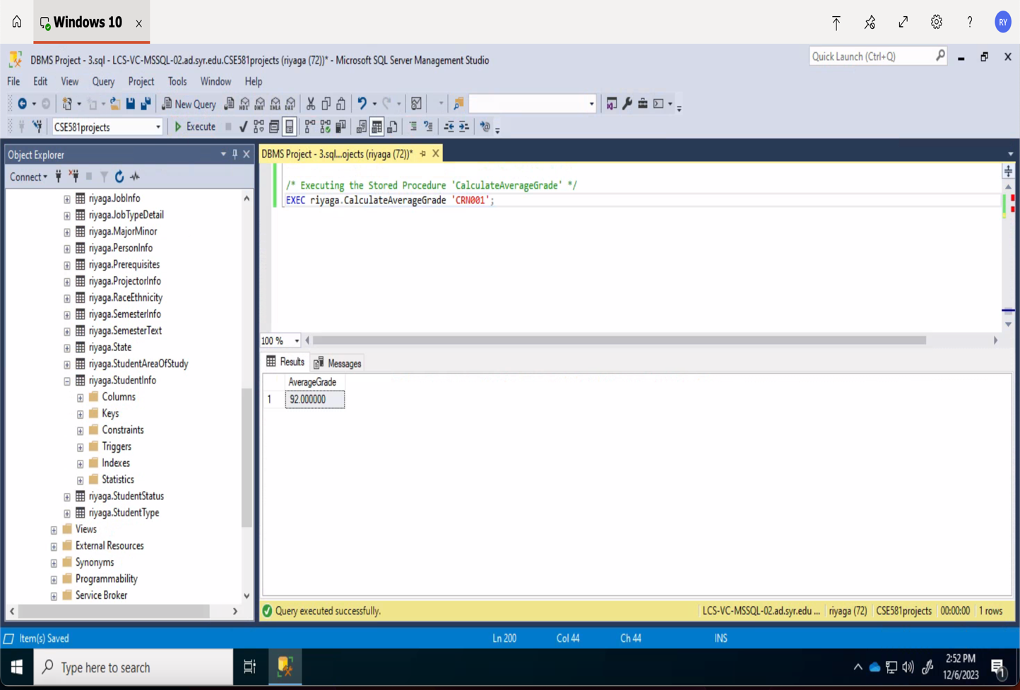

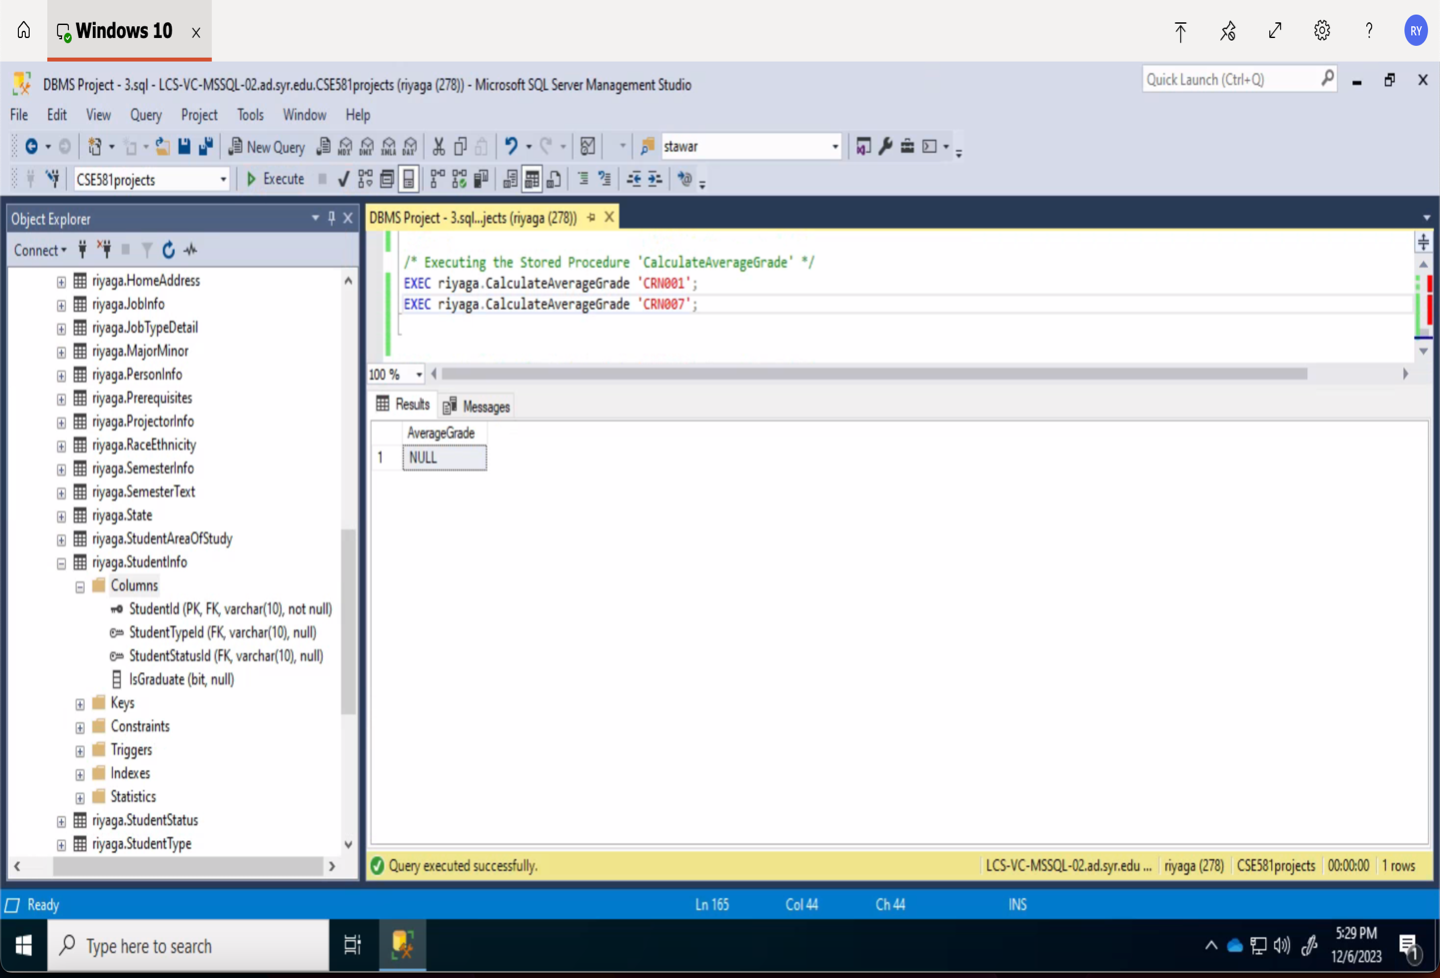

***SELECT STATEMENTS:***

1. Executing the view 'Benefits'

SELECT * FROM riyaga.Benefits;

1. Executing the Function 'GetTotalStudentsInMajor'

SELECT riyaga.GetTotalStudentsInMajor('M001') AS [Total Students in Major];

1. Executing the Stored Procedure 'GetAllStudentsWithCursor'

EXEC riyaga.GetAllStudentsWithCursor;

1. Executing the Stored Procedure 'UpdateStudentStatus'

EXEC riyaga.UpdateStudentStatus 'P001', 'SS003';

EXEC riyaga.UpdateStudentStatus 'P007', 'SS003';

SELECT * FROM riyaga.StudentInfo;

1. Executing the Stored Procedure 'DeleteStudent'

EXEC riyaga.DeleteStudent 'P004';

EXEC riyaga.DeleteStudent 'P007';

SELECT * FROM riyaga.StudentInfo;

1. Executing the Stored Procedure 'CalculateAverageGrade'

EXEC riyaga.CalculateAverageGrade 'CRN001';

EXEC riyaga.CalculateAverageGrade 'CRN007';